UNIT IV
Networking
A network is two or more computers (or other electronic devices) that are connected together, usually by cables or Wi-Fi. Some computer networks will have a server. A server is a powerful computer that often acts as a central hub for services in a network, eg emails, internet access and file storage.
Types of Computer Networks
- Personal Area Network (PAN)
- Local Area Network (LAN)
- Wide Area Network (WAN)
- Metropolitan Area Network (MAN)
Personal Area Network (PAN) :
PAN is the most basic type of computer network. This network is restrained to a single person, that is, communication between the computer devices is centered only to an individual’s work space. PAN offers a network range of 10 meters from a person to the device providing communication.
Examples of PAN are USB, computer, phone, tablet, printer, PDA, etc.
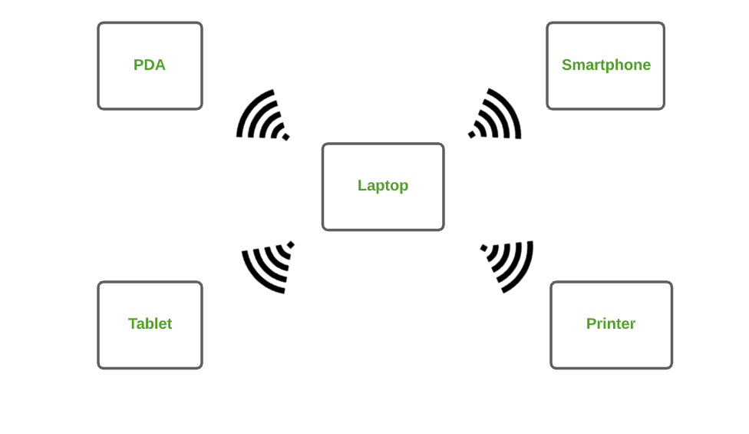
2. Local Area Network (LAN) :
LAN is the most frequently used network. A LAN is a computer network that connects computers together through a common communication path, contained within a limited area, that is, locally. A LAN encompasses two or more computers connected over a server. The two important technologies involved in this network are Ethernet and Wi-fi.
Examples of LAN are networking in a home, school, library, laboratory, college, office, etc.
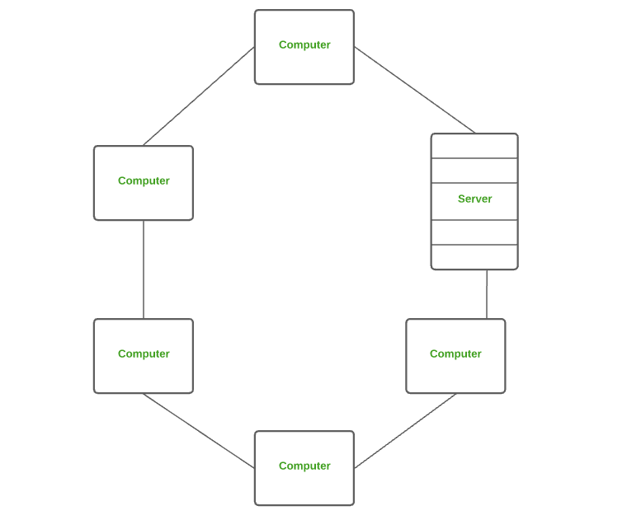
3. Wide Area Network (WAN) :
WAN is a type of computer network that connects computers over a large geographical distance through a shared communication path. It is not restrained to a single location but extends over many locations. WAN can also be defined as a group of local area networks that communicate with each other.
The most common example of WAN is the Internet.
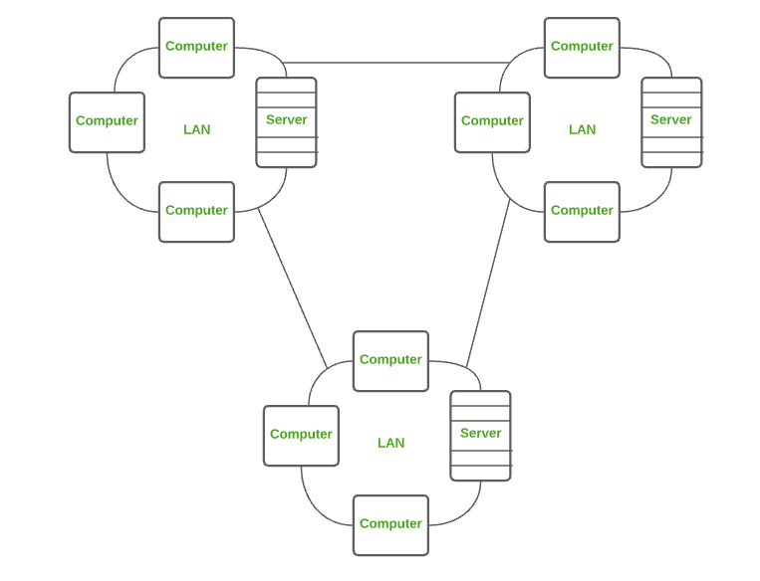
4.Wireless Local Area Network (WLAN) :
WLAN is a type of computer network that acts as a local area network but makes use of wireless network technology like Wi-Fi. This network doesn’t allow devices to communicate over physical cables like in LAN but allows devices to communicate wirelessly.
The most common example of WLAN is Wi-Fi.
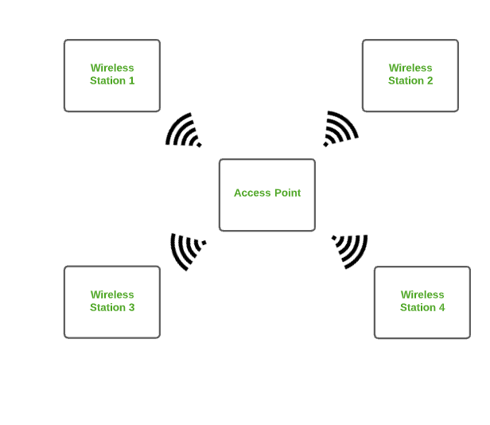
Metropolitan Area Network (MAN) :
A MAN is larger than a LAN but smaller than a WAN. This is the type of computer network that connects computers over a geographical distance through a shared communication path over a city, town or metropolitan area.
Examples of MAN are networking in towns, cities, a single large city, large area within multiple buildings, etc.
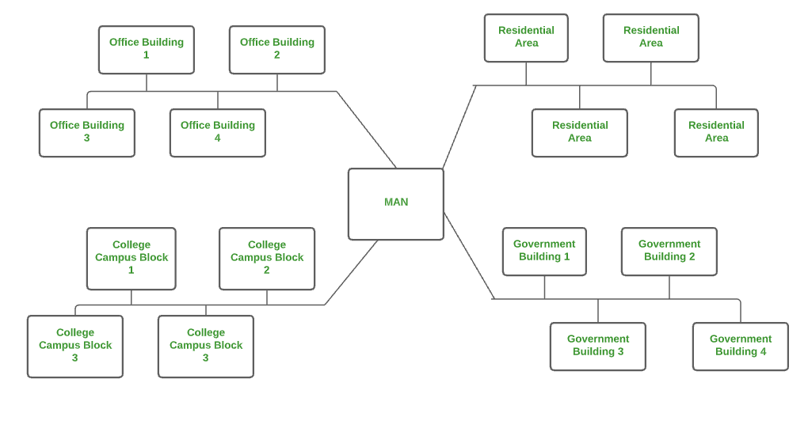
Transmission Control Protocol
TCP (Transmission Control Protocol) is one of the main protocols of the Internet protocol suite. It lies between the Application and Network Layers which are used in providing reliable delivery services. It is a connection-oriented protocol for communications that helps in the exchange of messages between different devices over a network. The Internet Protocol (IP), which establishes the technique for sending data packets between computers, works with TCP.
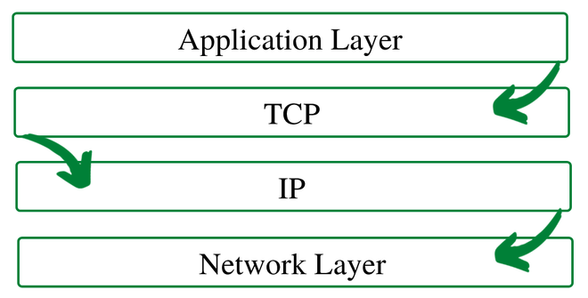
TCP/IP Layer

- Application Layer: The application layer makes sure that the data from the sending end is received in a format that is acceptable and supported at the receiving end.
- Transport Layer: The transport layer is responsible for the smooth transmission of data from one end to the other. It is also responsible for reliable connectivity, error recovery, and flow control of the data.
- Internet Layer: This Internet Layer moves packets from source to destination by connecting independent networks.
- Network Access Layer: The Network Access Layer sees how a computer connects to a network.
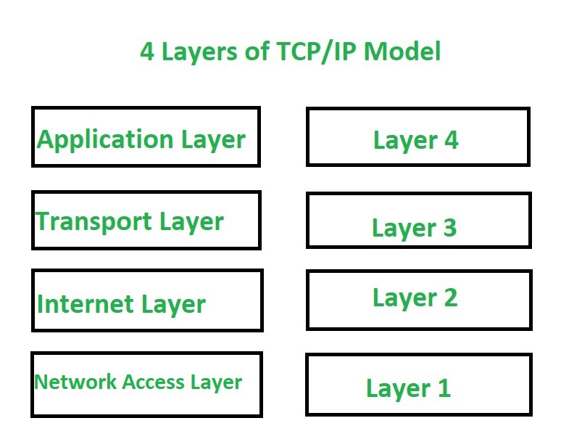
Data processing and File Processing

File based system | Database system
1. The data and program are inter- dependent. | 1. The data and program are independent of each other.
2. File-based system caused data redundancy. The data may be duplicated in different files | 2. Database system control data redundancy. The data appeared only once in the system.
3. File –based system caused data inconsistency. The data in different files may be different that cause data inconsistency. | 3. In database system data always consistent. Because data appeared only once.
4. The data cannot be shared because data is distributed in different files. | 4. In database data is easily shared because data is stored at one place.
5. In file based system data is widely spread. Due to this reason file based system provides poor security. | 5. It provides many methods to maintain data security in the database.
6. File based system does not provide consistency constrains. | 6. Database system provides a different consistency constrains to maintain data integrity in the system.
7. File based system is less complex system. | 7. Database system is very complex system.
8. The cost of file processing system is less then database system. | 8. The cost of database system is much more than a file processing system.
9. File based system takes much space in the system, and memory is wasted in this approach. | 9. Database approach store data more efficiently it takes less space in the system and memory is not wasted.
10. To generate different report to take a crucial decision is very difficult in file based system. | 10. The report can be generated very easily in required format in database system. Because data in database is stored in an organized manner. And easily retrieve to generate different report.
11. File based system does not provide concurrency facility. | 11. Database system provides concurrency facility.
12. File based system does not provide data atomicity functionality. | 12. Database system provides data atomicity functionality.
13. The cost of file processing system is less than database system. | 13. The cost of database system is more than file processing system.
14. It is difficult to maintain as it provides less controlling facility. | 14. Database provides many facility to maintain program.
15. If one application fail it does not affects other files in system. | 15. If database fail it affects all application that dependent on database
16. Hardware cost is less than database system | 16. Hardware cost is high in database than file system.

Difference between Multiprocessing and Multiprogramming
S.No. | Multiprocessing | Multiprogramming
1. | The availability of more than one processor per system, that can execute several set of instructions in parallel is known as multiprocessing. | The concurrent application of more than one program in the main memory is known as multiprogramming.
2. | The number of CPU is more than one. | The number of CPU is one.
3. | It takes less time for job processing. | It takes more time to process the jobs.
4. | In this, more than one process can be executed at a time. | In this, one process can be executed at a time.
5. | It is economical. | It is economical.
6. | The number of users is can be one or more than one. | The number of users is one at a time.
7. | Throughput is maximum. | Throughput is less.
8. | Its efficiency is maximum. | Its efficiency is Less.
System Architecture
A system architecture is a representation of a system in which there is a mapping of functionality onto hardware and software components, a mapping of the software architecture onto the hardware architecture, and human interaction with these components.
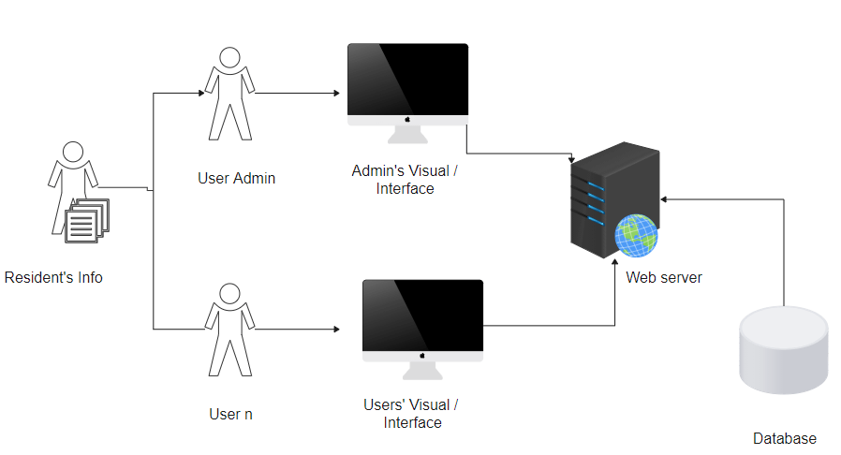

ISP Types
ISPs can broadly be classified into six categories as shown in the following diagram:
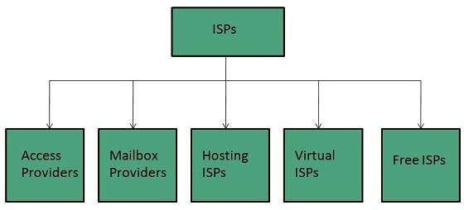

Access providers
They provide access to internet through telephone lines, cable wi-fi or fiber optics.

Mailbox Provider
Such providers offer mailbox hosting services.

Hosting ISPs
Hosting ISPs offers e-mail, and other web hosting services such as virtual machines, clouds etc.

Virtual ISPs
Such ISPs offer internet access via other ISP services.

Free ISPs
Free ISPs do not charge for internet services.

Connection Types
There exist several ways to connect to the internet. Following are these connection types available:
- Dial-up Connection
- ISDN
- DSL
- Cable TV Internet connections
- Satellite Internet connections
- Wireless Internet Connections

Dial-up Connection
Dial-up connection uses telephone line to connect PC to the internet. It requires a modem to setup dial-up connection. This modem works as an interface between PC and the telephone line.
There is also a communication program that instructs the modem to make a call to specific number provided by an ISP.
Dial-up connection uses either of the following protocols:
- Serial Line Internet Protocol (SLIP)
- Point to Point Protocol (PPP)
The following diagram shows the accessing internet using modem:
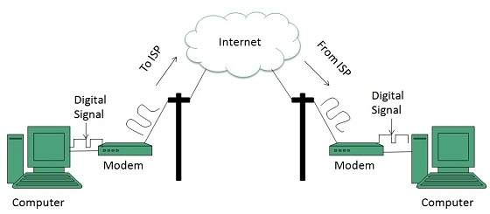

ISDN
ISDN is acronym of Integrated Services Digital Network. It establishes the connection using the phone lines which carry digital signals instead of analog signals.
There are two techniques to deliver ISDN services:
- Basic Rate Interface (BRI)
- Primary Rate Interface (PRI)

Requirements of e-payment systems
Requirements
Important characteristics for an Internet payment system include security, reliability, scalability, anonymity, acceptability, customer base, flexibility, convertibility, efficiency, ease of integration with applications, and ease of use. Some of these characteristics, like anonymity, are more important in some communities, or for certain kinds of transactions, than they are in other communities. These characteristics are presented for discussion and comparison. The NetCheque and NetCash systems meet some of these characteristics better than other systems, but make trade- offs with respect to some of the other characteristics.

Security
Since payments involve actual money, payment systems will be a prime target for criminals. Since Internet services are provided today on networks that are relatively open, the infrastructure supporting electronic commerce must be usable and resistant to attack in an environment where eavesdropping and modification of messages is easy.
Reliability

As more commerce is conducted over the Internet, the smooth running of the economy will come to depend on the availability of the payment infrastructure, making it a target of attack for vandals. Whether the result of an attack by vandals or simply poor design, an interruption in the availability of the infrastructure would be catastrophic. For this reason, the infrastructure must be highly available and should avoid presenting a single point of failure.
Scalability
As commercial use of the Internet grows, the demands placed on payment servers will grow too. The payment infrastructure as a whole must be able to handle the addition of users and merchants without suffering a noticeable loss of performance. The existence of central servers through which all transactions must be processed will limit the scale of the system. The payment infrastructure must support multiple servers, distributed across the network.
Anonymity
For some transactions, the identity of the parties to the transaction should be protected; it should not be possible to monitor an individual's spending patterns, nor determine one's source of income. An individual is traceable in traditional payment systems such as checks and credit cards. Where anonymity is important, the cost of tracking a transaction should outweigh the value of the information that can be obtained by doing so.
Acceptability
The usefulness of a payment mechanisms is dependent upon what one can buy with it. Thus, a payment instrument must be accepted widely. Where payment mechanisms are supported by multiple servers, users of one server must be able to transact business with users of other servers.
Customer base
The acceptability of a payment mechanism is affected by the size of the customer base, i.e. the number of users able to make payments using the mechanism. Merchants want to sell products, and without a large enough base of customers using a payment mechanism, it is often not worth the extra effort for a merchant to accept the mechanism.
Flexibility

Alternative forms of payment are needed, depending on the guarantees needed by the parties to a transaction, the timing of the payment itself, requirements for auditability, performance requirements, and the amount of the payment. The payment infrastructure should support several payment methods including instruments analogous to credit cards, personal checks, cashier's checks, and even anonymous electronic cash. These instruments should be integrated into a common framework.
Convertibility

Users of the Internet will select financial instruments that best suit their needs for a given transaction. It is likely that several forms of payment will emerge, providing different tradeoffs with respect to the characteristics just described. In such an environment it is important that funds represented by one mechanism be easily convertible into funds represented by others.
Efficiency
Royalties for access to information may generate frequent payments for small amounts. Applications must be able to make these "micropayments" without noticeable performance degradation. The cost per transaction of using the infrastructure must be small enough that it is insignificant even for transaction amounts on the order of pennies.
Ease of integration
Applications must be modified to use the payment infrastructure in order to make a payment service available to users. Ideally, a common API should be used so that the integration is not specific to one kind of payment instrument. Support for payment should be integrated into request-response protocols on which applications are built so that a basic level of service is available to higher level applications without significant modification.
Ease of use
Users should not be constantly interrupted to provide payment information and most payments should occur automatically. However, users should be able to limit their losses. Payments beyond a certain threshold should require approval. Users should be able to monitor their spending without going out of their way to do so.

How to book train ticket online; step by step guide
Step 1: Visit the IRCTC e-ticketing website: www.irctc.co.in.
Step 2: Login to the IRCTC website by using user id, password.
Step 3: You can either login with OTP facility or by entering the captcha code. If opting the OTP facility, enter the One Time Password (OTP) sent on the registered mobile number to log in.
Step 4: Fill the railway stations between which you wish to travel, ‘source station’ and ‘destination station’ on the ‘Book Your Ticket’ on the homepage of the IRCTC website.
Step 5: Enter the date of journey and class of travel.
Step 6: Click on ‘Find Trains’.
Step 7: The list of trains available on the selected route will be shown.
Step 8: Click on ‘check availability and fare’ to check the seat availability and fare of the selected class, sleeper class, 3 tier, 2 tier, 1 AC, Chair Car, Executive Car, etc.
Step 9: Select the train with which you want to travel, subject to the availability of the train tickets, and click on ‘Book Now’.
Step 10: Confirm train ticket booking by clicking on ‘Ok’ on the new dialogue box.
Step 11: Enter passenger details such as name, age, gender, food choice, seat preference, mobile number, preferred coach id (if any). Enter the details of the child, if travelling with children below 5 years of age.
Step 12: Enter the verification code and click on ‘Continue Booking’.
Step 13: Click on ‘Continue Booking’ again on the review booking page.
Step 14: Select the payment method from the options available such as credit card, debit card, net banking, mobile wallet and pay the required amount on payment window.

Discuss about online booking systems in any one domain.

Rate Plans
An online booking system must be able to deal with multiple scenarios for any given stay. You should be able to set multiple conditional rates for a room, or a property, for any given date range. These conditional rates should include:
- Rates based on time before arrival (Early or Late Bookings)
- Occupancy Based (Number of people)
- Length-of-stay based rates (longer you stay, cheaper it is)
- Add ons (Activities, Optional Extras, etc.)
- Discounts (Voucher or Codes)
Yield Manager, or Automated Rates, are great for larger operations but if you are running a small operation, they might not be as useful as you may think. However, don’t be fooled!! Automated rates do not happen on ttheir own, as you still have to set rates, plus conditions that the system should apply to calculate the rate at any given time. It is not a magic!

2. Channel Management
These days it is impossible for any hospitality business to get away from OTAs (Online Travel Agencies or Channels) such as Booking.com, Expedia, AirBnB, Homeaway, etc.
The chances are you will have to sell via 3rd parties (portals/OTA), therefore your system should be able to manage inventory, bookings, and ideally rates by linking up to external databases and booking systems. This is very important for Hotels, B&Bs, and Vacation Rental Properties regardless of the size of the operation.
If your channel inventory and your real inventory are not synchronised, there is a high chance of overbooking and embarrassing conversations, as well as poor reviews. These could also cost dearly as most portals and booking agencies ask you to commit to finding an equivalent room for their guests at your cost.

3. Guest Management
Customer experience has become the key differentiating factor in hospitality sector. Remember your customer experience starts from when they begin their journey through your website, reservation process, and right up to the moment they leave your establishment.
This means you need to communicate effectively from the moment they make a reservation. This means, your booking system is an integral part of customer experience. Automation in the process enables you to predict requirements, anticipate, and act. From reminders for payment, to providing directions, to advice on local facilities (car rental, restaurants, parking, etc.), is all about making the holiday an enjoyable experience rather than a “Challenge Tour”.
Your booking system should be able to take care of this for you, and unburden your staff so that they can concentrate on providing service to the guests that are at the premises.

4. Payment Processing
Online booking system should be capable of handling payments. Common payment methods such as PayPal, Stripe, Authorize.net, etc., should be built in or at least be easy to integrate.
Online payments do have additional costs, so beware of commission and transaction charges. Your system should be able to integrate with your credit card company’s gateway. However, these are typcially not click-and-go as each bank has their own Gateway and API. You may also have to comply with the credit card company’s requirements such as SSL certification, refund policy, etc. Make sure you factor these costs in, or ask your vendor about the options they can offer you to reduce or mitigate some of these costs.
Additionally, the system should allow you to choose how to offer deals based on payment method. For example, non-refundable rates which payment is taken upfront, Deposit Only Rates, No Deposit Rates or No Cancellation rates that all have different payment options.

5. House Keeping
The online booking system should be able to handle room status, so that you can produce lists for housekeeping and maintenance.
This does require internal discipline, as staff need to be trained to use the system effectively, but the upside is better visibility of any potential issues with rooms, and ultimately preventing customer complaints.

6. Billing
Whilst most larger hotels have their own billing systems, most smaller B&Bs and boutique hotels do not have a dedicated accounting packages.
For smaller operations, your booking system needs to be able to produce accurate, itemised, and professional looking invoices.
For larger operations, your booking system should be able to integrate with your accounting system using their respective API. Make sure your accounting system does have an API for the booking system to connect to, but also check if there is any licensing costs. Most booking systems offer their API at no cost, but you do need to pay for it to be integrated with your accounting system.

Summary
There are many options available for hospitality businesses looking for online booking system. The key in selection process is understanding your own needs clearly, and asking the right questions. Do not allow yourself to be distracted by clever whiz-bang aesthetic design, as they do not help with customer satisfaction, nor would they make your life any easier. Focus on functionality and whether the system is right for the way you operate.
Find out the true cost and not just the headline price. Costs include website integration, payment gateway integration, management time, and reliability.
We offer a range of support services for Small and Large hotels including fully featured Web Hosting and Online Booking Systems. We also offer a fully managed services for both Web Hosting and Online Reservation Systems.

